**IOT BASED AUTOMATIC WATERING SYSTEM FOR PLANTS**



**A PROJECT REPORT**

*Submitted by*

**Jaskaran UID: 18BEM1034**

**Ankit UID: 18BEM1012**

***In partial fulfillment for the award of the degree***

***of***

**BACHELOR OF ENGINEERING**

**in**

**MECHATRONICS ENGINEERING**

**Under the Guidance**

**Of**

**Inderpreet Singh**

**University Institute of Engineering**

**CHANDIGARH UNIVERSITY**

**NOVEMBER – 2021**

**CHANDIGARH UNIVERSITY**

**BONAFIDE CERTIFICATE**

Certified that this project report **“ IoT Based automatic watering System for plants”**

is the bonafide work of

**Jaskaran UID: 18BEM1034**

**Ankit UID: 18BEM1012**

who carried out the work under my supervision. Certified further that to the best of my knowledge the work reported herein does not form part of any other thesis or dissertation on the basis of which a degree or award was conferred on an earlier occasion on this or any other candidate.



Signature of the Head of the Department Signature of the Supervisor

**SIGNATURE SIGNATURE**

Dr. Harjot Singh Inderpreet Singh

**HEAD OF THE DEPARTMENT SUPERVISOR**

Assistant Professor

Mechatronics Department Mechatronics Department

University Institute of Engineering University Institute of Engineering

Chandigarh University Chandigarh University



**CERTIFICATE FOR EVALUATION**

**College Name : University Institute of Engineering**

**Branch : Mechatronics Engineering.**

**Year / Semester: IV / VII**

|  |  |  |  |
| --- | --- | --- | --- |
| **S.NO** | **Name of the Students**  **Who have done**  **the project** | **Title of the project** | **Name of the**  **Supervisor with**  **Designation** |
| **1.** | **Jaskaran** | IOT BASED AUTOMATIC WATERING SYSTEM FOR PLANTS | Mr.Inderpreet Sir  Designation-Asst. Prof |
| **2.** | **Ankit** |

The reports of the project work submitted by the above students in partial fulfillment for the award of Bachelor of Engineering degree in Mechatronics Engineering of Chandigarh University were evaluated and confirmed to be the reports of the work done by the above students and then evaluated.

**INTERNAL EXAMINER EXTERNAL EXAMINER**



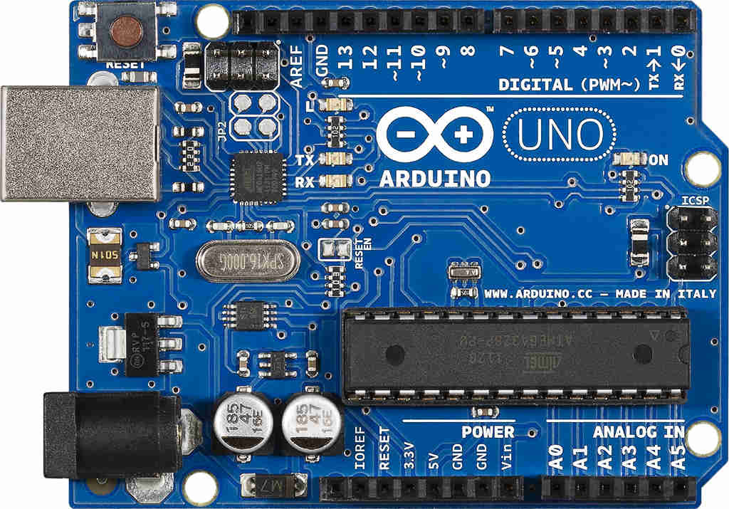

**ACKNOWLEDGEMENT**

This project, though done by us would not have been possible, without the support of various people, who by their cooperation have helped us in bringing out this project successfully.

Our special heartfelt thanks to Chairperson **Prof. Gurmeet Singh** for providing ate of art facility during project work.

We are grateful to our Principal, **Dr. Harjot Singh Gill**  for his patronage towards our project.

We thank our Professor & Head**, Asst. Prof. Anurag Sharma**  who had always served as an inspiration for us to perform well.

We would like to express our faithful thanks to **Inderpreet Singh,** for having extended all the department facilities without slightest hesitation.

We would like to express our unbounded gratefulness to **Mr. Anurag Sharma** and **Mr. Pulkit Jain** for their valuable guidance and encouragement throughout the project.

We thank all faculty members and supporting staff for the help they extended to us for the completion of this project.



**ABSTRACT :**

. Health sectors are given extreme importance in this pandemic period by each country with the advent of the novel corona virus (Covid-19). In this aspect, an IoT based health monitoring system is the best option to check and have informed about the patient health from a far distance. Internet of Things (IoT) is the new revolution of internet which is growing research area especially in health care. With the increase in the use of wearable sensor and smart phones these remote health care monitoring has evolved in such a pace. IoT monitoring system helps in preventing the spread of disease. In this paper, our health monitoring system is displayed which uses numerous electrical sensor to displayed the patient heartbeat, temperature displayed over the Blynk App. We also use Wi-Fi module to store the patient data and basis of these values given by the system doctor diagnosed the patient from a distance



**TABLE OF CONTENTS**

|  |  |  |
| --- | --- | --- |
| **TITLE** | | **PAGE NO.** |
| **ACKNOWLEDGEMENTS……………………………………………………** | | i |
| **ABSTRACT…………………………………………………………………….** | | ii |
| **TABLE OF CONTENTS………………………………………………………** | | iii |
|  | |  |
| 1. **INTRODUCTION** 2. **LITERATURE SURVY** 3. **METHODLOGY**     1. **Material Utilized & Cost**    2. **Component Description**    3. **Work Done**    4. **Output** | |  |
|  |  | |
| **REFERENCES………………………………………………………………..** |  | |
|  |  | |

**I INTRODUCTION**

Health is always a major concern in every growth. The human race is advancing in terms of technology like in recent corona virus attack that has ruined the economy of almost all the world. In such area where the epidemic is spread it is always a better idea to monitor these patients using remote health monitoring technology. So the IoT based health monitoring system is the current solution for it.

The health care is vast area require continuous monitoring , measurement of patient parameter such as heart rate, blood pressure , body temperature .When accurate and immediate decision making are crucial, electronic monitoring have be extensively used to collect and display physiological data. A patient monitoring system may not only alter caregivers to potentially life threatening events, many also provide physiology input data to control directly connected life support device. The core objective of this project is to design and implementation of a smart health and uses internet to inform their loved ones in case of any issue through Blynk app. The objective of developing monitoring systems is to reduce health care costs.

In most of the rural area the medical facility would not be in a hand reach distance for the natives. So normally people physically visit their office. Each of our bodies utilizes temperature and also pulse acknowledging to persue understanding wellbeing. The sensors are linked to a microcontroller to track the status which is thus interfaced to our phone screen through app. If it finds any sudden change in understanding heart beat or body temperature it consequently alarms the clients about the patient status over IoT. There is a significant capability between neglect any kind of minor health issues which is shown in early stages by variation of vital elements like body temperature, heart rate etc.

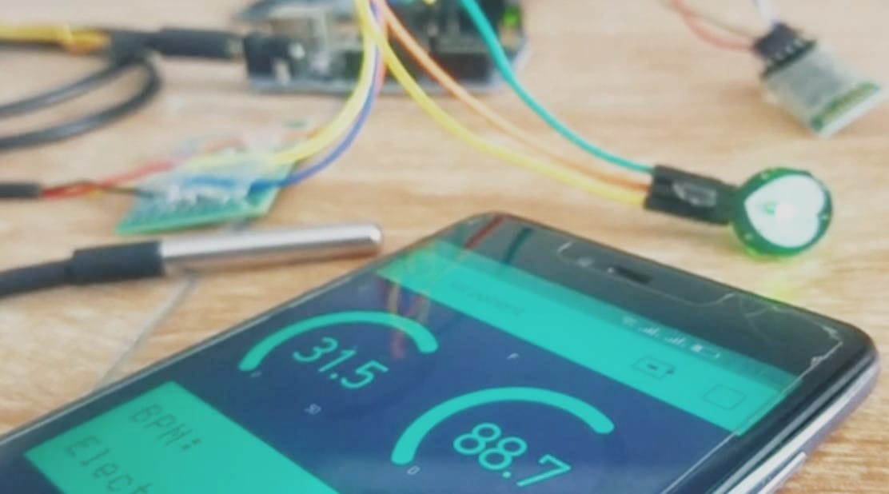

**II LITERATURE SURVEY**

There are many framework regarding the IoT based health monitoring system already on board so here we mention some of the framework which already had been made by different person using different system/technology.

* **A Low Cost IoT system for multi patient ECG monitoring**

M. Ryan Fajar Nurdin, Sugondo Hadiyoso and Achmad Rizal presented a prototype that is forced to work only on transmission of Electrocardiographic signal through zigbee wirelessly. By attaching different sensor to different nodes in the body, they collected a series of data which is an analog form and made a web application for showing the respective readings according to the patient. There application is limited to the 20 patients onlyanf the contains different bandwidth issue which cause erroes in proposed result.

* **IoT based health monitoring system**

Naina Gupta et al. Put forward a structure which aims to resolve the issue of time wastage during the ambulatory services and in hospitals , they forces to send the data via GSM module connect through the Bluetooth technology. Routine health checkup and monitoring the different body parameter with the help of the different sensors attached to the body is the main focus. They focus on developing a small size wearable system that can transfer the data through GPRS to custom networks.

* **IoT based health monitoring system using Raspberry Pi**

Ashwini Gatte et al. Proposed an IoT based fitness tracking system of aged person in which he used different parameters of body glucose, blood pressure, heart rate as well actively monitoring with the help of Raspberry Pi, he also used ECG sensor for heartbeat and other disease. He also proposed different IoT based protocols which can be used in this type of system.

* **An efficient wireless health monitoring system**

Chowdhary et al. Proposed a system with a GSM module connected to a Raspberry Pi in an assembly of different health monitoring sensors. This system focus on directly transfer of health data in form of direct message on the phone of doctor. They aim to make it portable and hence to decrease the load of in the hospital for patient monitoring. They obtained the speed of 20 seconds per reading for refreshing the updated value and storing the data in the system.

* **A wireless continuous patient monitoring system for dengue; Wi-Mon**

The system is developed by Nubenthan and Ravi Chelvan using a wireless interface for WBAN using IEEE 802.15.6 standards. They separated the hardware and usec Wi-Mon software to collect the data from different sensor. This information provide the idea of patient seriousness in any disease like Dengue. Collection of vital information such as body temperature, pulse rate, ECG, oxygen saturation and blood pressure are used as a base material to monitor the health with the accuracy of Wi-Mon software.

* **Literature gap**

Although there are nothing in particular to bring change in our project because all the project are on same level and almost have same component and working principal but according to time with advancement in sensor it could be further modified.

**III METHODOLOGY**

* 1. **Material Utilize & Cost**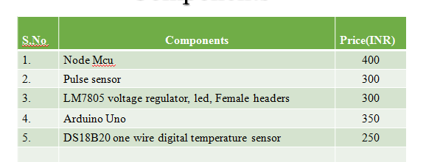
  2. **Component Description**
* ***Arduino Uno***

Arduino uno is an open source electronic device board. This board is equipped with various sets of digital and analog input/output pins that can be interfaced to various expansion board and other circuits. In the table II there are some features of Arduino uno and specification as per our project requirement. 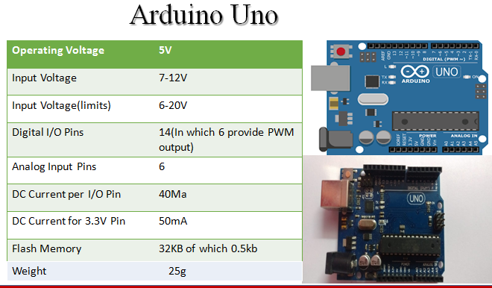

* ***Pulse Sensor:***

Pulse sensor is a well designed plug and play heart rate sensor for Arduino. It can be used artisits,athletes , maker, and game and mobiledevelopers who want to easily incorporate live heart-rate data into their project.

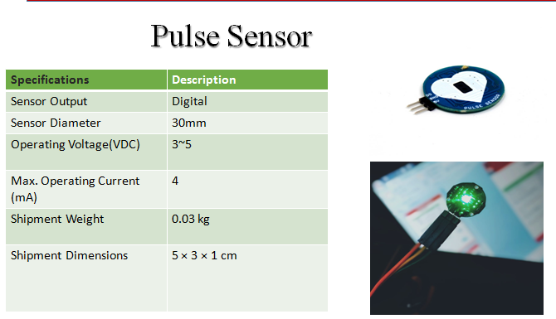

* ***NodeMCU ESP8266:***

NodMCU is a low-cost open source IoT platform. It initially included firmware which runs on the ESP8266 Wi-Fi SoC from Espressif System, and hardware which was based on the ESP-12 module. Later support fot the ESP32 32-bit MCU was added.

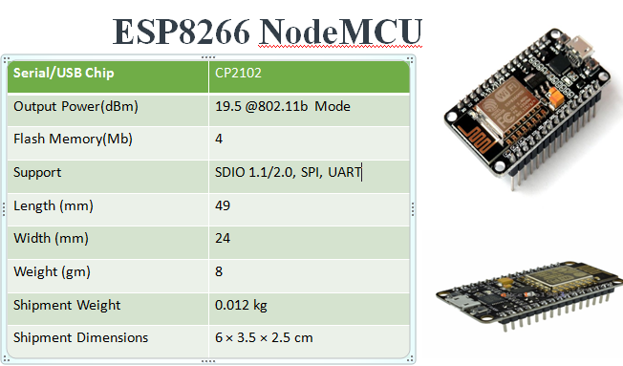

* 1. **Work Done**

**Work done by Nihit Shyam**

* Patient monitoring designing and making
* Wiring of components
* Report Writing

**Work done by Prince Raj**

* Selection of component
* Design and making
* Literature Review
  1. **Output**

This project aims to design an IoT based patient monitoring system. The temperature sensor and pulse sensor is directly connected to arduino board and regulated power supply is given to the NodMCU board along with arduino board. Our Bluetooth module gain power from NodeMCU and groud pin connected to NodeMCU and other pin attached with arduino board. That is our roughly pin diagram.

Besides this there are different coding for different boards and according to that rest of the pins attached to there allocated locations. And we have separate option for our Blynk app in which the patient health data given through wireless connection or Bluetooth module, through which we can monitor the patient health directly in our phone.

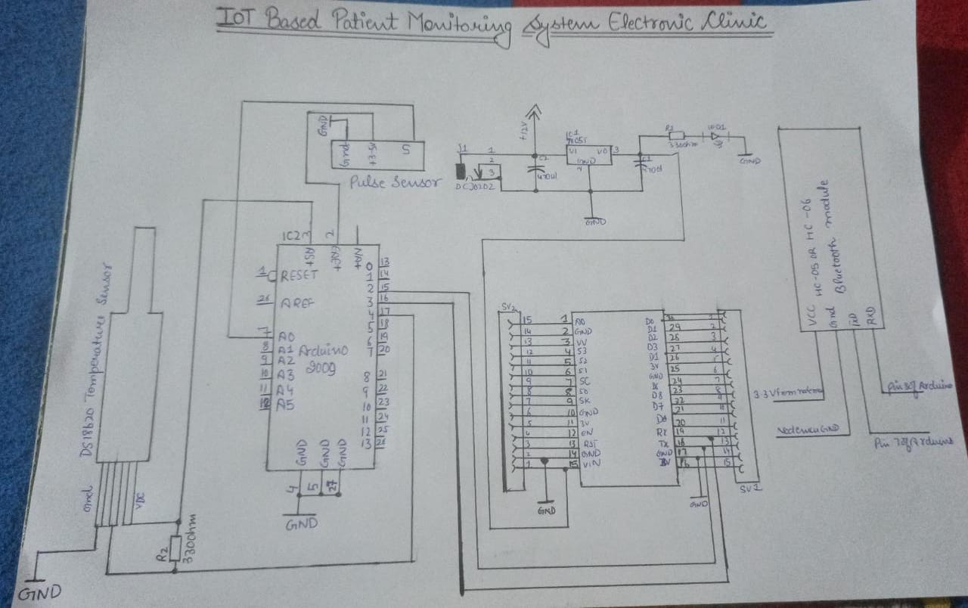

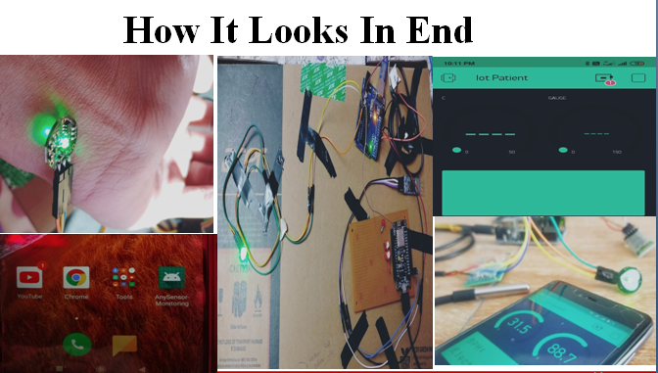

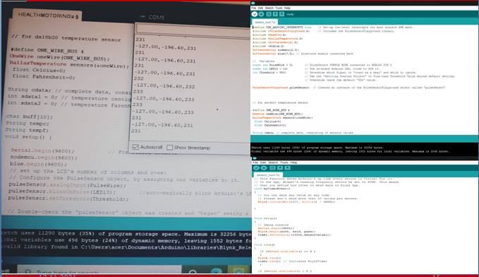

**References:**

[1] N. M. Kumar and A. Dash, “The Internet of Things : An Opportunity for Transportation and Logistics,” no. June, 2018.

[2] W. Z. Khan, M. K. Afzal, and K. Salah, “Industrial Internet of Things : Recent Advances , Enabling Technologies , and Open Challenges Industrial Internet of Things : Recent Advances , Enabling Technologies and Open Challenges,” no. November, 2019.

[3] T. Alladi, V. Chamola, R. M. Parizi, and K. R. Choo, “Blockchain Applications for Industry 4 . 0 and Industrial IoT : A Review,” *IEEE Access*, vol. 7, pp. 176935–176951, 2019.

[4] S. Kumar, P. Tiwari, and M. Zymbler, “Internet of Things is a revolutionary approach for future technology enhancement : a review,” *J. Big Data*, 2019.

[5] A. H. Hussein, “Internet of Things ( IOT ): Research Challenges and Future Applications,” vol. 10, no. 6, pp. 77–82, 2019.

[6] A. H. Hussein, “Internet of Things ( IOT ): Research Challenges and Future Applications,” vol. 10, no. 6, pp. 77–82, 2019.

[7] A. Abubaker, C. R. Kavya, T. Thomas, N. Joseph, and S. Begum, “A Study on IOT Approach for Monitoring Water Quality Using MQTT Algorithm,” pp. 3329–3331, 2018.

[8] P. S. Mathew, A. S. Pillai, and V. Palade, “Applications of IoT in Healthcare,” 2018.

[9] R. Revathi, S. Vijani, and S. Vijanu, “Intelligent health care services based on Iot,” *Int. J. Sci. Eng. Res.*, vol. 6, no. 4, pp. 500–503, 2015.

[10] Z. Ning *et al.*, “A cooperative quality-aware service access system for social internet of vehicles,” *IEEE Internet Things J.*, vol. 5, no. 4, pp. 2506–2517, 2018.

[11] K. Gupta *et al.*, “Survey paper on Traffic Management System using IOT for Emergency Vehicles,” pp. 4804–4812, 2021.

[12] V. N. Malavade and P. K. Akulwar, “Role of IoT in Agriculture,” *Natl. Conf. "Changing Technol. Rural Dev.*, vol. 1, no. 13, pp. 56–57, 2016.